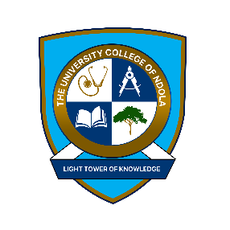

The University College of Ndola
Application Form

Step 1: Student details
NRC/Passport:
First name: | Middle name(s):
Surname/Family name: | Date of Birth:
Residential Address:

Country: | Town:
Phone 1 | Phone 2
Email:

Differently Abled:
ANY SPECIAL NEEDS:
Please state nature of any special needs below. Please include any other impairment/medical conditions that you feel we should be made aware of:
Please tick if the below are relevant:
Blind or visually impaired |  | ☐ Yes ☐ No
Hearing loss or impairment |  | ☐ Yes ☐ No
Learning disability |  | ☐ Yes ☐ No
Epilepsy |  | ☐ Yes ☐ No
Diabetes |  | ☐ Yes ☐ No

STEP 3: NEXT OF KIN
Name:
Relationship to student:
Address: | Tick here if same address as student ☐
Phone number:
Email address:

SPONSOR
Name:
Relationship to student:
Address: | Tick here if same address as student ☐
Phone number:
Email address:

STEP 4: ACADEMIC DETAILS
Please select Programme below by ticking
Bachelors of Arts In Human Resources Management | ☐
Bachelor of Science In Biomedical Sciences | ☐
Bachelor of Art In Business Administration | ☐
Bachelor of Science In Architecture | ☐

STEP 4: ACADEMIC DETAILS

Please email the completed form, Copies of Grade twelve or equivalent Certificate(s), NRC and Proof of payment for the form

Signature: | Date:

Please return the completed application form to the email address below

admissions@tun.ac.zm

Buteko Avenue, Ndola Central Business District
P. O Box 70335, Ndola Zambia
admissions@tun.ac.zm
+260- 957612042
If you require any help in completing this application, please contact us through the details shown above.
Please return the completed application form to the email address above

